|  |  |
| --- | --- |
|  | |
| Macleay Street and Wolloomooloo Village Summary Report 2012 | City of Sydney  Town Hall House  456 Kent Street  Sydney NSW 2000 |
| City of Sydney Floor Space and Employment SurveyC:\City of Sydney Data\Village Reports\Village - CBD North\CBD and Harbour Figure Title Page.jpg |  |
|  | |

# Macleay Street and Wolloomooloo Village

## Introduction

The City of Sydney undertakes its comprehensive Floor Space and Employment Survey (*FES*) every five years to coincide with the Australian Bureau of Statistics’ Census of Population and Housing. The latest FES is the second to encompass those areas amalgamated into the City of Sydney from the former South Sydney and Leichhardt Councils in 2004, and allows the City of Sydney to investigate and report on changes in workforce, businesses and floor space across Surveys.

The FES collects data on all businesses, floor space uses and employment numbers for every building or property within the City of Sydney local government area (LGA). It provides a snapshot of the built form, land uses and economic activity of the City of Sydney every five years. The field data captured for the current Survey was undertaken during 2012.

The data collection phase of the FES involves field surveyors visiting every business in the City of Sydney to determine what industry the business is in, how many workers are in each business, and the floor space use of each business through visual inspection and the use of existing floor space. Information for various capacity measures such as quantity of seating, parking, rooms and units are also collected. Residential uses are only surveyed from the street and validated by checking existing floor plans. The data is entered into a Geographic Information System (GIS) database to allow 2- and 3-dimensional mapping, analysis and reporting.

The data is used by both internal and external stakeholders as a basis for strategic planning, policy formulation, business development and forecasting.

The Macleay Street and Woolloomooloo Village encompasses the area from Garden Island in the north to William Street in the south and from Rushcutters Bay in the east to The Domain, in the west. The Village includes the suburbs of Woolloomooloo, Potts Point, Elizabeth Bay and Rushcutters Bay (see Figure 1).

The 2012 FES collected data from 1,235 sites in the Village, including 818 business premises. The total internal floor space surveyed was 2,240,270m², an increase of 0.6% from the previous Survey. A further 708,444m² of external area (including parks, backyards, balconies, pools etc.) was also collected in the data.

Figure 2 that follows shows the extent of the Macleay Street and Woolloomooloo Village, looking north east. Residential uses are shown in dark red and, as can be seen from the figure, they dominate the east of the Village, around Potts Point and Elizabeth Bay, which for many years has been the most densely populated residential area in Australia. Business uses are shown in light brown and are predominant in the west, along William Street, and in the north, where industrial and shipping business uses dominate the wharfs and ports of Woolloomooloo and Elizabeth Bay. Darlinghurst Road, the main street in Macleay Street and Woolloomooloo Village, also has a strong business presence. Other uses, such as common property, vacant or under construction are shown in yellow and blue respectively.

Figure 1: Macleay Street and Woolloomooloo Village Location Map

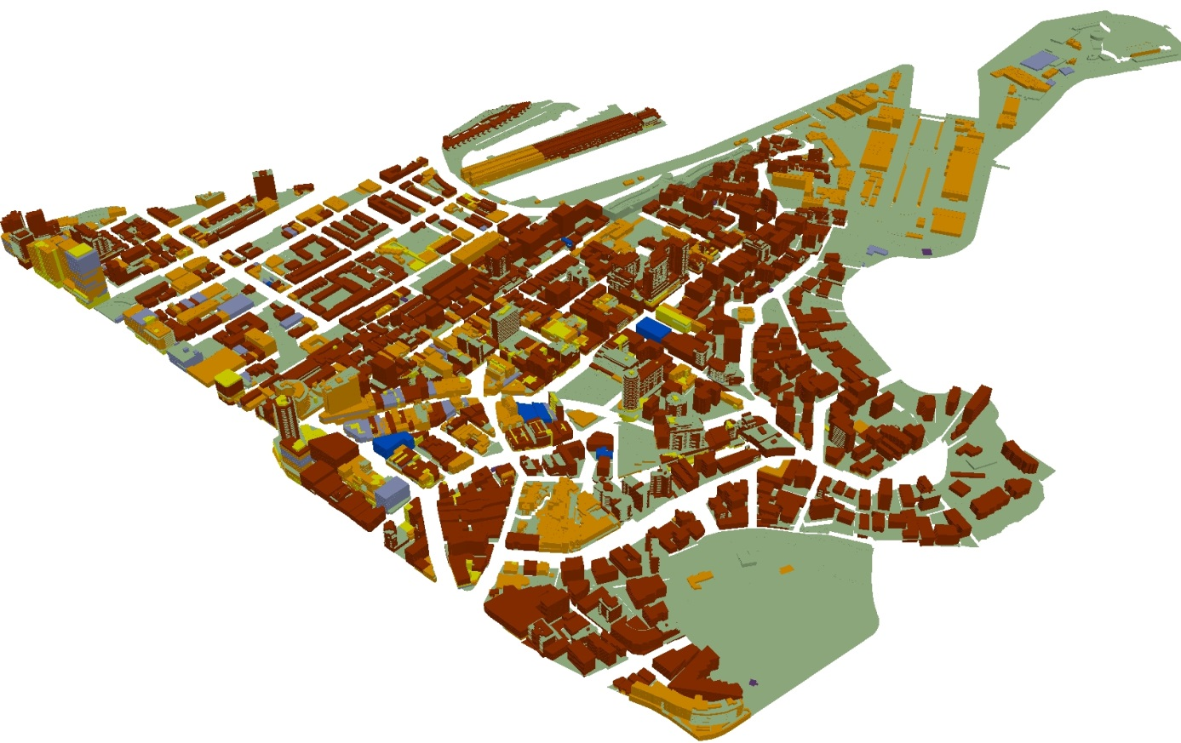

Figure 2. Macleay Street and Woolloomooloo Village looking northwest.

In 2006, the Australian Bureau of Statistics (ABS) Estimated Resident population (ERP) stated that there were 18,822 residents living in Macleay Street and Woolloomooloo Village. By 2011, the ERP for Macleay Street and Woolloomooloo Village had risen to 19,516, an increase of 3.7% over five years. The proportion of the City of Sydney’s residents in Macleay Street and Woolloomooloo Village fell from 11.4% in 2006 to 10.6% in 2011. As of 2011, the Macleay Street and Woolloomooloo Village is the fifth most populous of the City of Sydney’s ten villages. It is estimated that Macleay Street and Woolloomooloo Village will accommodate approximately 20,456 (9.6%) of the City of Sydney’s residents by 2016, and 21,167 residents (7.8%) by 2031.[1] The percentage share of City of Sydney residents living in the area is forecast to gradually decline as other villages in the City of Sydney are set to experience strong residential growth, such as Green Square and City South Village which is the centre of a major urban renewal project.

The Macleay Street and Woolloomooloo Village resident population was housed in 12,930 dwellings at the time of the Survey. The dwelling stock of the Village is dominated by multi-storey apartment blocks (with 86.5% of dwellings) and terrace houses (7.9%). There was a 1.9% increase in the number of dwellings between the two Surveys. Over the next few years, residential development will increase with at least 320 new units expected to be added to the residential stock.[2]

Employment in the Macleay Street and Woolloomooloo Village decreased by 1.1% between the Surveys, from 9,620 in 2007 to 9,511 in 2012, and was the only village in the City of Sydney to do so. The proportion of full-time employment decreased from 79.6% in 2007 to 68.8% in 2012.

There were an additional 65 businesses surveyed in 2012 compared to 2007, an increase of 8.6%. Over the same period, the average number of workers per business decreased from 12.77 to 11.63.

The number of parking spaces in the Village increased by only 3 between 2007 and 2012.

When looking at Visitor Accommodation in the Village, there has been an increase in the number of rooms between the Surveys. The stock of hotel rooms expanded by 271 rooms, or 14.6%, while the number of backpacker beds increased by 512 or 31.9%.

The key totals for the 2007 and 2012 Surveys are shown in Table 1 below.

|  |  |  |  |  |
| --- | --- | --- | --- | --- |
| **Table 1. Key Totals for Macleay Street and Woolloomooloo Village, 2007-2012** | | | | |
| **Category** | **2007** | **2012** | **Change** | **% Change** |
| **General** |  |  |  |  |
| Sites Surveyed | 1,235 | 1,235 | 0 | 0.0% |
| Buildings Surveyed | 1,190 | 1,194 | 4 | 0.3% |
| Businesses Surveyed | 753 | 818 | 65 | 8.6% |
| **Areas** |  |  |  |  |
| Internal Floor Area (m²) | 2,226,695 | 2,240,270 | 13,575 | 0.6% |
| External Area (m²) | 708,901 | 708,444 | -457 | -0.1% |
| Total Surveyed Area (m²) | 2,935,596 | 2,948,714 | 13,118 | 0.4% |
| **Employment** |  |  |  |  |
| Full-time Employment | 7,662 | 6,548 | -1,114 | -14.5% |
| Part-time Employment | 1,958 | 2,963 | 1,005 | 51.3% |
| Total Employment | 9,620 | 9,511 | -109 | -1.1% |
| **Residential** |  |  |  |  |
| Number of Dwellings | 12,684 | 12,930 | 246 | 1.9% |
| Buildings with Dwellings | 924 | 935 | 11 | 1.2% |
| Population | 18,822 | 19,516 | 694 | 3.7% |
| Occupancy Rate | 1.48 | 1.51 | - | - |
| **Tenant Parking** |  |  |  |  |
| Internal Parking Spaces | 6,834 | 6,831 | -3 | 0.0% |
| External Parking Spaces | 1,235 | 1,241 | 6 | 0.5% |
| Total Parking Spaces | 8,069 | 8,072 | 3 | 0.0% |
| **Visitor Accommodation** |  |  |  |  |
| Hotel Accommodation (Rooms) | 1,857 | 2,128 | 271 | 14.6% |
| Serviced Apartments (Units) | 234 | 302 | 68 | 29.1% |
| Backpacker Accommodation (Beds) | 1,603 | 2,115 | 512 | 31.9% |

## Industry Classification

The FES codes each business establishment based on a modified Australian and New Zealand Standard Industrial Classification (ANZSIC) – 2006. ANZSIC classifies the primary activity of a business into 16 ‘Divisions’ and then into 506 4-digit ‘Industries’. The Survey has further subdivided these into 644 unique business uses. This allows for more detailed analysis of business, employment and floor space uses.

The 644 business uses have been re-categorised into a ‘City-Based Industry Sector’ Classification based on the method used by the City of Greater London. This classification better reflects the mix of uses within the business community of city centres such as the City of Sydney. There are nineteen ‘business’ related industry divisions, and a further five ‘non-business’ related industry divisions within the City-Based Industry Sector Classification. This allows the analysis of industry groups such as *Creative Industries*, *Information and Communication Technologies (ICT)* and *Tourist, Cultural and Leisure*.

Table 2 (following) shows the breakdown by City-Based Industry of employment, businesses and (business) floor space for the Macleay Street and Woolloomooloo Village in 2012. During the Survey, data was collected on 818 businesses; there were 9,511 workers counted; and businesses occupied 637,759m² of internal floor space. These figures make Macleay Street and Woolloomooloo Village the smallest village amongst the ten City of Sydney villages in terms of business numbers, and the second smallest for employment and business floor space. Only King Street Village has a smaller number of businesses and Glebe Point Road Village has a smaller Business Floor Area. This suggests that the Macleay Street and Woolloomooloo Village is more residentially dominant than commercial.

The predominant Industry Sector in terms of business establishments in the Macleay Street and Woolloomooloo Village is *Food and Drink*, with over a quarter of the total number of businesses. However, employment is highest in the *Government* sector followed by *Tourist, Cultural and Leisure*. Three Industry Sectors employ more than 1,000 workers within the Macleay Street and Woolloomooloo Village (*Government*, *Tourist, Cultural and Leisure* and *Food and Drink*). The Village has a less diversified industry mix than other villages, with 7 of the 19 industry sectors registering less than 10 establishments. Tables 3, 5 and 6 (following) show the changes in the number of businesses, employment and business floor space use by each of the City-Based Industry Sectors between 2007 and 2012.

### Business Establishments

Between 2007 and 2012 the number of businesses in the Macleay Street and Woolloomooloo Village increased by 8.6%, from 753 to 818 businesses. The largest sectoral increase occurred in the *Food and Drink* Industry, with an additional 51 business establishments compared to 2007. There were an additional 21 *Retail and Personal Services* businesses compared to 2007. There was an absolute increase in the number of business establishments in only nine of the nineteen sectors.

Of the 753 business located in the Village in 2007, 520 were still operating in the same location in 2012. A number of industry sectors had significant levels of new business commencement, including *Food and Drink, Professional and Business Services* and *Retail and Personal Services*. Each of these three industry sectors experienced relatively high turnover coupled with overall growth in the number of establishments per industry. The area’s predominant industry, *Food and Drink*, had the largest business turnover number (44 ceasing or moving operation, with 95 commencing), whilst at the same time showing the largest growth in absolute numbers (51 establishments).

|  |  |  |  |  |  |  |
| --- | --- | --- | --- | --- | --- | --- |
| **Table 2. Overview of City-Based Industry Sectors, Macleay Street and Woolloomooloo Village, 2012** | | | | | | |
| **City-Based Industry Sector** | **Businesses** | **% of Total Businesses** | **Employment** | **% of Total Employment** | **Business Floor Area** | **% Business Floor Area** |
| Community | 9 | 1.1% | 413 | 4.3% | 16,231 | 2.5% |
| Creative Industries | 60 | 7.3% | 726 | 7.6% | 28,786 | 4.5% |
| Finance and Financial Services | 28 | 3.4% | 198 | 2.1% | 5,085 | 0.8% |
| Food and Drink | 211 | 25.8% | 1,405 | 14.8% | 31,844 | 5.0% |
| Government | 38 | 4.6% | 1,791 | 18.8% | 209,467 | 32.8% |
| Health | 28 | 3.4% | 951 | 10.0% | 33,813 | 5.3% |
| Higher Education and Research | 3 | 0.4% | 7 | 0.1% | 253 | 0.0% |
| ICT | 12 | 1.5% | 167 | 1.8% | 2,451 | 0.4% |
| Life Science (Bio-tech) | 7 | 0.9% | 38 | 0.4% | 744 | 0.1% |
| Manufacturing | 0 | 0.0% | 0 | 0.0% | 0 | 0.0% |
| Motor Vehicle | 13 | 1.6% | 125 | 1.3% | 9,273 | 1.5% |
| Natural Resource-Based Industries | 0 | 0.0% | 0 | 0.0% | 0 | 0.0% |
| Other* | 0 | 0.0% | 88 | 0.9% | 0 | 0.0% |
| Professional and Business Services | 77 | 9.4% | 852 | 9.0% | 20,092 | 3.2% |
| Property Development and Operation | 25 | 3.1% | 162 | 1.7% | 3,507 | 0.5% |
| Retail and Personal Services | 123 | 15.0% | 389 | 4.1% | 13,231 | 2.1% |
| Social Capital | 51 | 6.2% | 423 | 4.4% | 24,462 | 3.8% |
| Tourist, Cultural and Leisure | 117 | 14.3% | 1,543 | 16.2% | 207,105 | 32.5% |
| Transport and Logistics | 16 | 2.0% | 233 | 2.4% | 30,717 | 4.8% |
| Utilities** | 0 | 0.0% | 0 | 0.0% | 697 | 0.1% |
| Total | 818 | 100.0% | 9,511 | 100.0% | 637,759 | 100.0% |

*’Other’ industry sector data may include nil businesses, nil employment and/or nil business floor area. This is explained by: the inclusion of non-private households which employ staff, such as student accommodation and aged care facilities; and, workers counted in common areas of multi-tenanted buildings who are not directly linked to a business establishment.

**‘Utilities’ industry sector data may include nil businesses, nil employment and /or nil business floor area. This is explained by the presence of substations or pumping stations (business floor area data that has not been directly linked to a business establishment).

|  |  |  |  |  |  |  |
| --- | --- | --- | --- | --- | --- | --- |
| **Table 3. Business Mix By City-Based Industry Sectors, Macleay Street and Woolloomooloo Village, 2007-2012** | | | | | | |
| **City-Based Industry Sector** | **2007** | **% of 2007 Businesses** | **2012** | **% of 2012 Businesses** | **Change 2007-2012** | **% Change 2007-2012** |
| Community | 8 | 1.1% | 9 | 1.1% | 1 | 12.5% |
| Creative Industries | 76 | 10.1% | 60 | 7.3% | -16 | -21.1% |
| Finance and Financial Services | 40 | 5.3% | 28 | 3.4% | -12 | -30.0% |
| Food and Drink | 160 | 21.2% | 211 | 25.8% | 51 | 31.9% |
| Government | 38 | 5.0% | 38 | 4.6% | 0 | 0.0% |
| Health | 22 | 2.9% | 28 | 3.4% | 6 | 27.3% |
| Higher Education and Research | 2 | 0.3% | 3 | 0.4% | 1 | 50.0% |
| ICT | 25 | 3.3% | 12 | 1.5% | -13 | -52.0% |
| Life Science (Bio-tech) | 10 | 1.3% | 7 | 0.9% | -3 | -30.0% |
| Manufacturing | 1 | 0.1% | 0 | 0.0% | -1 | -100.0% |
| Motor Vehicle | 15 | 2.0% | 13 | 1.6% | -2 | -13.3% |
| Natural Resource-Based Industries | 0 | 0.0% | 0 | 0.0% | 0 | NA |
| Other | 0 | 0.0% | 0 | 0.0% | 0 | NA |
| Professional and Business Services | 66 | 8.8% | 77 | 9.4% | 11 | 16.7% |
| Property Development and Operation | 21 | 2.8% | 25 | 3.1% | 4 | 19.0% |
| Retail and Personal Services | 102 | 13.5% | 123 | 15.0% | 21 | 20.6% |
| Social Capital | 45 | 6.0% | 51 | 6.2% | 6 | 13.3% |
| Tourist, Cultural and Leisure | 104 | 13.8% | 117 | 14.3% | 13 | 12.5% |
| Transport and Logistics | 17 | 2.3% | 16 | 2.0% | -1 | -5.9% |
| Utilities | 1 | 0.1% | 0 | 0.0% | -1 | -100.0% |
| Total | 753 | 100.0% | 818 | 100.0% | 65 | 8.6% |

|  |  |  |  |
| --- | --- | --- | --- |
| **Table 4. Recent and Established Businesses By City-Based Industry Sectors, Macleay Street and Woolloomooloo Village, 2012** | | | |
|
| **City-Based Industry Sector** | **Established (Pre-2008)** | **Commenced 2008-2012** | **% Established** |
| Community | 9 | 0 | 100.0% |
| Creative Industries | 44 | 16 | 73.3% |
| Finance and Financial Services | 14 | 14 | 50.0% |
| Food and Drink | 116 | 95 | 55.0% |
| Government | 36 | 2 | 94.7% |
| Health | 20 | 8 | 71.4% |
| Higher Education and Research | 0 | 3 | 0.0% |
| ICT | 5 | 7 | 41.7% |
| Life Science (Bio-tech) | 5 | 2 | 71.4% |
| Manufacturing | 0 | 0 | NA |
| Motor Vehicle | 10 | 3 | 76.9% |
| Natural Resource-Based Industries | 0 | 0 | NA |
| Other | 0 | 0 | NA |
| Professional and Business Services | 30 | 47 | 39.0% |
| Property Development and Operation | 14 | 11 | 56.0% |
| Retail and Personal Services | 79 | 44 | 64.2% |
| Social Capital | 39 | 12 | 76.5% |
| Tourist, Cultural and Leisure | 88 | 29 | 75.2% |
| Transport and Logistics | 11 | 5 | 68.8% |
| Utilities | 0 | 0 | NA |
| Total | 520 | 298 | 63.6% |

Figures 3a and 3b (following) show the percentage share of the top six City-Based Industry Sectors in 2007 and 2012. *Food and Drink* remains the largest percentage share of total businesses increasing 4.6% since 2007 to account for over a quarter of businesses in 2012 (25.8%). *Retail and Personal Services* replaces *Tourist, Cultural and Leisure* as the second largest percentage share. *Creative Industries* experienced the only decrease of the top six industries to be replaced by *Professional and Business Services* as the fourth largest percentage share. Whilst there was minor reshuffling amongst positions within the top six, the industry sectors that make up the top six have not changed from 2007 to 2012. This indicates a relatively stable business mix in the Macleay Street and Woolloomooloo Village.

Overall, the top six industry sectors increased their combined share by 4.7% driven almost entirely by growth in the *Food and Drink* industry. The difference between the dominant industry sector, *Food and Drink*, and the second largest business sector increased by 3.4%, extending the overall lead of *Food and Drink* to 10.8% in business numbers. These figures show there was less diversification amongst businesses in Macleay and Woolloomooloo Street Village in 2012 compared to 2007.

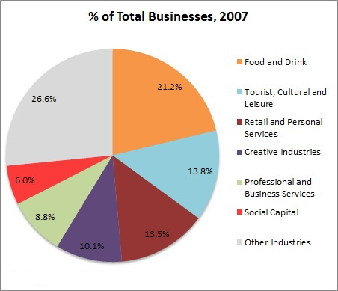

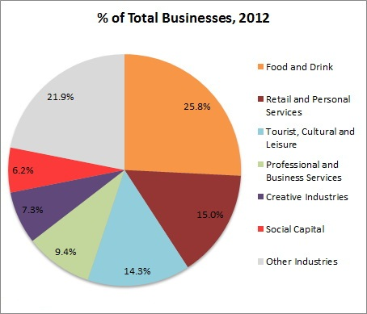

Figure 3a. Percentage Share of Top Six Industry Sectors, 2007

Figure 3b. Percentage Share of Top Six Industry Sectors, 2012

### Employment

In the period between the Surveys, employment in the Macleay Street and Woolloomooloo Village decreased by 1.1% or 109 workers. There were 9,511 workers counted in 2012 across nineteen different industry sectors. Only eight of the nineteen sectors experienced employment growth, with *Tourist, Cultural and Leisure* adding the most with 376 additional workers. The *Government* industry remains the largest employer, with 1,791 employees, even after a loss of 458 workers. This equates to 18.8% of the total employment in the Village. The *Government* industry also has the highest number of workers per business with 47.1. The Macleay Street and Woolloomooloo Village has no employment in *Manufacturing*, making it the only Village in the LGA with no representation in this sector.

Table 5 (following) shows the breakdown of employment by City-Based Industry Sector for 2007 and 2012, with the percentage share of each sector and the change between Surveys. The *Health* sector had the highest percentage employment growth for any sector employing over 200 workers at 48.1%. *Community, Professional and Business Services, Social Capital* and *Tourist, Cultural and Leisure* added approximately a third of their worker numbers again over a five year period.

Eleven sectors in the Macleay Street and Woolloomooloo Village experienced decline in employment, the most of any Village. However, this was largely offset by the gains in employment in the remaining sectors, as there was only a total employment loss of 109. As previously mentioned, the largest loss of employment was in the *Government* sector where there was a loss of 458 workers, without any loss of establishments, resulting in an increased work space ratio (WSR) for the *Government* sector.

In 2012, businesses in Macleay Street and Woolloomooloo Village employed 11.6 workers on average across all sectors. The number of workers per business ranged from a high of 47.1 in the *Government* sector, down to a low of 2.3 for businesses in the *Higher Education and Research* sector. The average number of workers per establishment in 2007 was 12.8.

The following figures (4a and 4b) illustrate the proportion of employment across the top six industry sectors in 2007 and 2012 respectively. The *Government* sector had the highest proportion of employment in both 2007 and 2012. However, its percentage share fell over the period from 23.4% in 2007 down to 18.8% in 2012.

The *Tourist, Cultural and Leisure* sector increased by 4.1% replacing the *Food and Drink* sector as the second largest share of total employment.

The *Creative Industries* sector fell from fourth to sixth after a fall of 2.7%. This was coupled with a percentage increase of both the *Professional and Business Services* and *Health* sectors, whichexperienced increases of 2.6% and 3.3% respectively.

Despite the significant decline in the *Government* sector the top six industries became more dominant in terms of employment share compared to the remaining industries, gaining an additional 4.7% share in 2012. This increase in concentration of employment enhances reliance on these industries as major employers and slightly reduces the diversity of the local economy.

However, the difference between the first and sixth largest sector has significantly dropped from 17% to 11.2% showing that the industries that make up the top six industry sectors are becoming more even in their share of employment.

|  |  |  |  |  |  |  |
| --- | --- | --- | --- | --- | --- | --- |
| **Table 5. Employment By City-Based Industry Sectors, Macleay Street and Woolloomooloo Village, 2007-2012** | | | | | | |
| **City-Based Industry Sector** | **2007** | **% of 2007 Employment** | **2012** | **% of 2012 Employment** | **Change 2007-2012** | **% Change 2007-2012** |
| Community | 302 | 3.1% | 413 | 4.3% | 111 | 36.8% |
| Creative Industries | 989 | 10.3% | 726 | 7.6% | -263 | -26.6% |
| Finance and Financial Services | 382 | 4.0% | 198 | 2.1% | -184 | -48.2% |
| Food and Drink | 1,234 | 12.8% | 1,405 | 14.8% | 171 | 13.9% |
| Government | 2,249 | 23.4% | 1,791 | 18.8% | -458 | -20.4% |
| Health | 642 | 6.7% | 951 | 10.0% | 309 | 48.1% |
| Higher Education and Research | 14 | 0.1% | 7 | 0.1% | -7 | -50.0% |
| ICT | 193 | 2.0% | 167 | 1.8% | -26 | -13.5% |
| Life Science (Bio-tech) | 253 | 2.6% | 38 | 0.4% | -215 | -85.0% |
| Manufacturing | 2 | 0.0% | 0 | 0.0% | -2 | -100.0% |
| Motor Vehicle | 181 | 1.9% | 125 | 1.3% | -56 | -30.9% |
| Natural Resource-Based Industries | 0 | 0.0% | 0 | 0.0% | 0 | NA |
| Other | 75 | 0.8% | 88 | 0.9% | 13 | 17.3% |
| Professional and Business Services | 613 | 6.4% | 852 | 9.0% | 239 | 39.0% |
| Property Development and Operation | 346 | 3.6% | 162 | 1.7% | -184 | -53.2% |
| Retail and Personal Services | 345 | 3.6% | 389 | 4.1% | 44 | 12.8% |
| Social Capital | 316 | 3.3% | 423 | 4.4% | 107 | 33.9% |
| Tourist, Cultural and Leisure | 1,167 | 12.1% | 1,543 | 16.2% | 376 | 32.2% |
| Transport and Logistics | 282 | 2.9% | 233 | 2.4% | -49 | -17.4% |
| Utilities | 35 | 0.4% | 0 | 0.0% | -35 | -100.0% |
| Total | 9,620 | 100.0% | 9,511 | 100.0% | -109 | -1.1% |

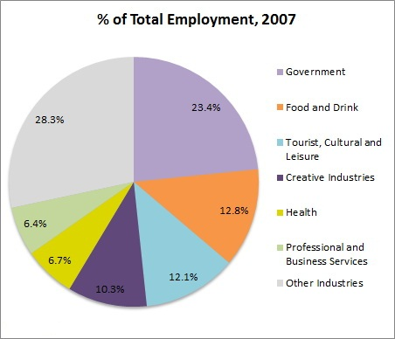

Figure 4a. Percentage Share of Top Six Industry Sectors, 2007

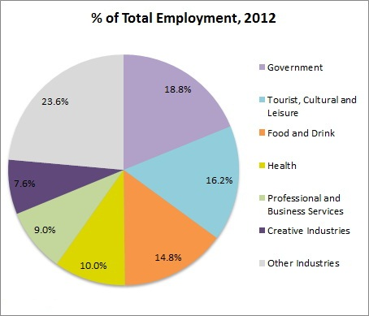

Figure 4b. Percentage Share of Top Six Industry Sectors, 2012

The following Figures (5 and 6) show the distribution of employment by block in 2012 and the change in employment numbers by block between 2007 and 2012 respectively. As can be seen in Figure 5, the majority of employment occurs in the northern portion of the Village, with concentrations of employment along William Street and Darlinghurst Road.

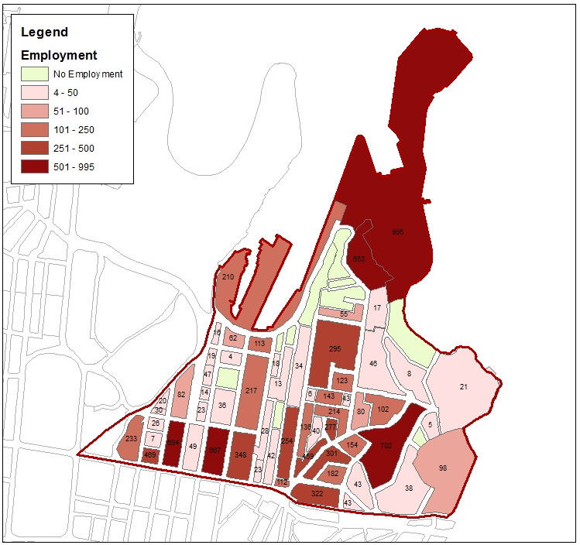

Figure 5. Total Employment by Block, 2012

Figure 6 below shows that high levels of employment growth have occurred around Darlinghurst Road. This area has a large late night economy and is therefore a centre point for business activity in the area. There is a concentration of employment loss in a block on William Street where there are a range of businesses operating. However, with the relocation of a major business’ headquarters from the block, it has experienced significant employment loss since 2007. In the north where the Australian Navy buildings are situated, two blocks experienced two very different employment changes. On the smaller of the sites, there was a loss of 583 employees while the bigger site increased by 187 workers.

### 

Figure 6. Total Employment Change by Block, 2007 to 2012

Figure 6. Total Employment Change by Block, 2007 to 2012

### Floor Area

The 2012 FES measured over 2.24 million square metres of internal floor space in the Macleay Street and Woolloomooloo Village. Additionally, data was collected on 708,444 square metres of external space, including parks, car parks, terraces and balconies. The measurements for the floor space uses were collected by creating spatial entities for each non-contiguous space, and attributing relevant attribute data such as employment numbers, capacity and vacancy to each. Every individual space is held in a Geographic Information System (GIS) database, and is related to the business that uses it. The GIS calculates the areas automatically, and allows 2-D and 3-D rendering of the data.

In terms of internal business floor area, the *Government* sector occupies the largest amount of floor space in the Village, with 209,467m². This sector and the *Tourist, Cultural and Leisure* sector, at 207,105m², are over 170,000m² more than the next largest floor space area.

The *Government* sector had the highest increase in floor area used, with an additional 20,758m² (an increase of 11%), whilst the *Manufacturing* sector had the greatest decline in floor area, with a loss of 20,114m² (100% decline), which was due to the loss of the only manufacturing business in the Village. Four industry’s floor space areas decreased by more than half and a further five by a quarter. Between the two Surveys, business floor space across all sectors fell by 32,425m²

The amount of Private *Household* floor area increased by 23,287m² between 2007 and 2012. There was a net increase of 246 dwellings during this period. As of 2012, there is approximately 1.35 million square metres of floor area in the *Private Household* sector, which is the largest space devoted to residential use of all the Villages in the LGA.

At the time of the Survey, approximately 88,321m² of internal floor area was vacant or under redevelopment, comprising 3.9% of all internal floor space, this is up from 3.7% in 2007.

|  |  |  |  |  |  |  |
| --- | --- | --- | --- | --- | --- | --- |
| **Table 6. Internal Floor Area By City-Based Industry Sectors, Macleay Street and Woolloomooloo Village, 2007-2012** | | | | | | |
| **City-Based Industry Sector** | **2007 m²** | **% of 2007 Floor Space** | **2012 m²** | **% of 2012 Floor Space** | **Change 2007-2012** | **% Change 2007-2012** |
| Community | 19,146 | 2.9% | 16,231 | 2.5% | -2,915 | -15.2% |
| Creative Industries | 39,274 | 5.9% | 28,786 | 4.5% | -10,489 | -26.7% |
| Finance and Financial Services | 7,475 | 1.1% | 5,085 | 0.8% | -2,390 | -32.0% |
| Food and Drink | 26,569 | 4.0% | 31,844 | 5.0% | 5,275 | 19.9% |
| Government | 188,710 | 28.2% | 209,467 | 32.8% | 20,758 | 11.0% |
| Health | 26,682 | 4.0% | 33,813 | 5.3% | 7,131 | 26.7% |
| Higher Education and Research | 469 | 0.1% | 253 | 0.0% | -216 | -46.0% |
| ICT | 3,740 | 0.6% | 2,451 | 0.4% | -1,288 | -34.5% |
| Life Science (Bio-tech) | 6,102 | 0.9% | 744 | 0.1% | -5,358 | -87.8% |
| Manufacturing | 20,114 | 3.0% | 0 | 0.0% | -20,114 | -100.0% |
| Motor Vehicle | 21,286 | 3.2% | 9,273 | 1.5% | -12,013 | -56.4% |
| Natural Resource-Based Industries | 0 | 0.0% | 0 | 0.0% | 0 | NA |
| Professional and Business Services | 15,702 | 2.3% | 20,092 | 3.2% | 4,391 | 28.0% |
| Property Development and Operation | 8,698 | 1.3% | 3,507 | 0.5% | -5,191 | -59.7% |
| Retail and Personal Services | 11,978 | 1.8% | 13,231 | 2.1% | 1,254 | 10.5% |
| Social Capital | 22,051 | 3.3% | 24,462 | 3.8% | 2,410 | 10.9% |
| Tourist, Cultural and Leisure | 222,000 | 33.1% | 207,105 | 32.5% | -14,895 | -6.7% |
| Transport and Logistics | 29,125 | 4.3% | 30,717 | 4.8% | 1,592 | 5.5% |
| Utilities | 1,063 | 0.2% | 697 | 0.1% | -366 | -34.4% |
| Total Business Floor Area | 670,184 | 100.0% | 637,759 | 100.0% | -32,425 | -4.8% |
|  |  |  |  |  |  |  |
| Private Households | 1,334,199 | 59.9% | 1,357,487 | 60.6% | 23,287 | 1.7% |
| Non-Private Households | 13,278 | 0.6% | 13,179 | 0.6% | -99 | -0.7% |
| Other | 126,675 | 5.7% | 143,525 | 6.4% | 16,850 | 13.3% |
| Redevelopment | 39,869 | 1.8% | 36,675 | 1.6% | -3,194 | -8.0% |
| Vacant | 42,490 | 1.9% | 51,646 | 2.3% | 9,156 | 21.5% |
| Total Businesses Floor Area | 670,184 | 30.1% | 637,759 | 28.5% | -32,425 | -4.8% |
| Total Floor Area | 2,226,695 | 100.0% | 2,240,270 | 100.0% | 13,575 | 0.6% |

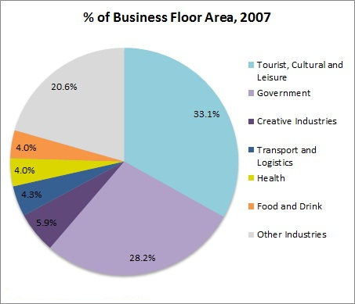

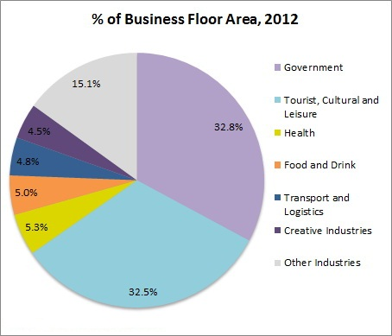

Figure 7b. Percentage Share of Top Six Industry Sectors by Floor Area, 2012

Figure 7a. Percentage Share of Top Six Industry Sectors by Floor Area, 2007

Figures 7a and 7b show the percentage share of business floor area for the top six industries in 2007 and 2012 respectively. *Tourist, Cultural and Leisure* had the highest share of floor space usage in 2007, although it dropped behind the *Government* sector in 2012 after the *Government* sector increased from 28.2% in 2007 to 32.8% in 2012.

The only two industry sectors within the top six that decreased their share of business floor area were *Tourist, Cultural and Leisure* (-0.6%) and the *Creative Industries* (-1.4%), which fell from third position in 2007 to sixth in 2012.

There were no other significant increases or decreases in business floor area over the five years between the surveys. The share of the top six industry sectors increased by 5.5% and the top two dominant sectors increased their combined share by 4%.

The average business is approximately 780m² in size across all sectors. This ranges from a low average business space of 84m² per establishment for *Higher Education and Research*, up to an average of 5,512m² of floor space use per establishment for the *Government* sector. The average floor area per business has decreased by approximately 110m² per establishment since 2007.

Figure 8 below maps the distribution of internal floor area by block for the Macleay Street and Woolloomooloo Village in 2012. The village is predominantly medium density development with a few pockets of higher density development in the east around Darlinghurst Road and in the north where the Australian Navy operate in the wharfs and bays.

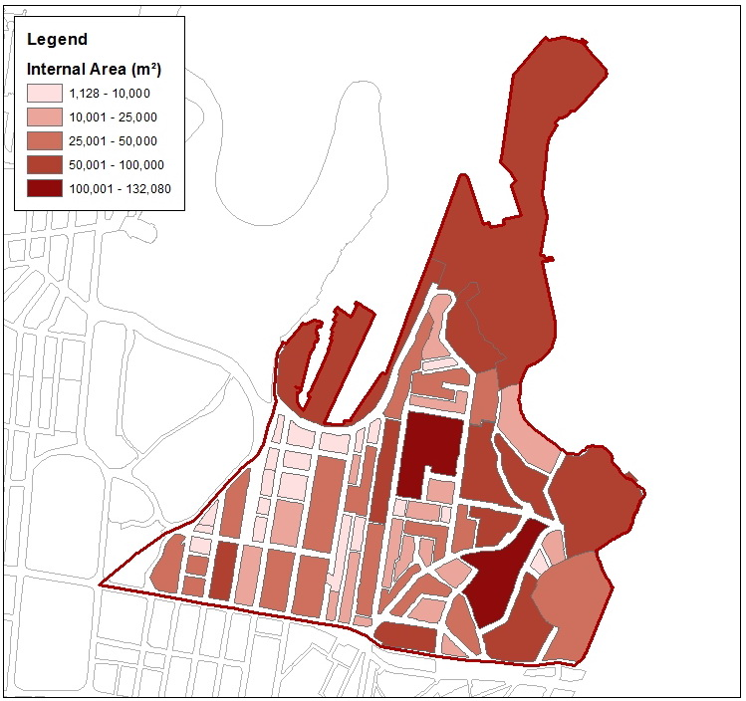

Figure 8. Total Internal Floor Space by Block, 2012

Figure 8. Total Internal Floor Space by Block, 2012

## Space Use

The City of Sydney Floor Space and Employment Survey collects data in three levels, from individual ‘Space Units’ (space uses), which belong to ‘Establishments’, which are located in ‘Buildings’. The FES data classifies all floor area within the LGA according to the way in which the space is used. Each space use is assigned a code, which is categorised according to fourteen different space use divisions. Space use codes are also used to record employment, seating capacities, dwelling and room numbers and parking spaces. These space uses can then be related to the industry use of each establishment, and the location of each building. For the Macleay Street and Woolloomooloo Village, there were 30,411 internal and 6,743 external individual space units recorded in 2012. This represents a 9.3% increase in the number of records collected compared to the 2007 Survey.

Table 7 indicates the internal floor area by Space Use Division within the Macleay Street and Woolloomooloo Village in 2007 and 2012. The Village is historically dominated by *Residential* development, which is the second largest, in terms of total floor area, of any of the Villages. Interestingly, this does not correspond with the total floor area for *Parking* space uses (*Parking* includes parking spaces, driveways, loading zones and bicycle parking) as it is sixth out of the ten villages. This suggests that the majority of *Residential* development in the Macleay Street and Woolloomooloo Village does not include parking spaces e.g. high rise flat developments. Looking at residential construction currently approved and underway, the percentage share of *Residential* space is set to increase in the short term.

The Macleay Street and Woolloomooloo Village’s total *Office* floor area is the second lowest of the ten City of Sydney villages. One of the more prominent space uses in the Village is *Visitor Accommodation*, as there are many backpacker hostels in the area, which increased by 6.2% over the five years from 2007 to 2012.

Table 8 shows the total employment by Space Use Division for the Macleay Street and Woolloomooloo Village in both 2007 and 2012. Those Space Uses with no employment (or minor employment) have been aggregated into the *Other* category.

Macleay Street and Woolloomooloo Village’s *Office* employment makes up 59.3% of all employment in the Village, falling from 68.7% after losing 972 workers since the last survey. The *Restaurant/Eating* Space Use Division holds the second highest number of workers with 1,857, or 19.5% of the total employment. Combined, these two Space Use Divisions make up approximately 80% of the total employment for the Village, down from over 84% in 2007.

The FES collects a number of capacity measures that are related to different types of space uses. The capacities are recorded for each individual space record. Table 9 following shows the capacity of restaurant seating, café seating, and meeting room/boardroom seating aggregated across the Village for 2007 and 2012.

In the five year period from 2007 to 2012, there was a 20.8% increase in the number of restaurant seats, with the number of restaurant establishments rising from 56 to 74 (32.1% increase). There was a 26.5% increase in café seating, with the number of café establishments rising from 46 in 2007 to 56 in 2012 (21.7% increase). Cafés in the Village have therefore increased the number of seats per establishment. In terms of the number of seats in meeting rooms (or boardrooms), this rose by 14.4% in the same period. This is in line with an increase of 5.7% of Office floor area. However, it is in contrast to the aforementioned fall of 972 workers in the Space Use Division.

|  |  |  |  |  |  |  |
| --- | --- | --- | --- | --- | --- | --- |
| **Table 7. Internal Floor Area by Space Use Division, Macleay Street and Woolloomooloo Village, 2007-2012** | | | | | | |
| **Space Use Division** | **2007 m²** | **% Floor Area 2007** | **2012 m²** | **% Floor Area 2012** | **Change 2007-2012** | **% Change 2007-2012** |
| Office | 196,105 | 8.8% | 207,197 | 9.2% | 11,092 | 5.7% |
| Shop/Showroom | 28,400 | 1.3% | 28,662 | 1.3% | 262 | 0.9% |
| Residential | 1,115,409 | 50.1% | 1,137,766 | 50.8% | 22,357 | 2.0% |
| Storage | 38,529 | 1.7% | 42,722 | 1.9% | 4,193 | 10.9% |
| Industrial | 44,597 | 2.0% | 45,759 | 2.0% | 1,162 | 2.6% |
| Visitor Accommodation | 112,580 | 5.1% | 119,558 | 5.3% | 6,979 | 6.2% |
| Entertainment/Leisure | 34,939 | 1.6% | 32,596 | 1.5% | -2,342 | -6.7% |
| Restaurant/Eating | 34,802 | 1.6% | 41,200 | 1.8% | 6,397 | 18.4% |
| Community | 15,930 | 0.7% | 15,232 | 0.7% | -697 | -4.4% |
| Utilities | 7,592 | 0.3% | 9,051 | 0.4% | 1,459 | 19.2% |
| Parking | 289,935 | 13.0% | 285,034 | 12.7% | -4,901 | -1.7% |
| Transport | 3,739 | 0.2% | 4,223 | 0.2% | 484 | 12.9% |
| Common Area | 205,202 | 9.2% | 208,183 | 9.3% | 2,982 | 1.5% |
| Other | 98,937 | 4.4% | 63,086 | 2.8% | -35,852 | -36.2% |
| Total | 2,226,695 | 100.0% | 2,240,270 | 100.0% | 13,575 | 0.6% |

|  |  |  |  |  |  |  |
| --- | --- | --- | --- | --- | --- | --- |
| **Table 8. Employment Mix by Space Use Division, Macleay Street and Woolloomooloo Village, 2007-2012** | | | | | | |
| **Space Use Division** | **2007** | **% Employment 2007** | **2012** | **% Employment 2012** | **Change 2007-2012** | **% Change 2007-2012** |
| Office | 6,613 | 68.7% | 5,641 | 59.3% | -972 | -14.7% |
| Shop/Showroom | 635 | 6.6% | 757 | 8.0% | 122 | 19.2% |
| Storage | 84 | 0.9% | 120 | 1.3% | 36 | 42.9% |
| Industrial | 224 | 2.3% | 430 | 4.5% | 206 | 92.0% |
| Entertainment/Leisure | 202 | 2.1% | 317 | 3.3% | 115 | 56.9% |
| Restaurant/Eating | 1,515 | 15.7% | 1,857 | 19.5% | 342 | 22.6% |
| Community | 310 | 3.2% | 289 | 3.0% | -21 | -6.8% |
| Utilities | 0 | 0.0% | 6 | 0.1% | 6 | NA |
| Transport | 24 | 0.2% | 6 | 0.1% | -18 | -75.0% |
| Other | 13 | 0.1% | 88 | 0.9% | 75 | 576.9% |
| Total | 9,620 | 100.0% | 9,511 | 100.0% | -109 | -1.1% |

|  |  |  |  |  |
| --- | --- | --- | --- | --- |
| **Table 9. Selected Capacity Measures, Macleay Street and Woolloomooloo Village, 2007-2012** | | | | |
| **Capacity Measure** | **2007** | **2012** | **Change 2007-2012** | **% Change 2007-2012** |
| Restaurant Seating | 3,926 | 4,744 | 818 | 20.8% |
| Cafe/Coffee Lounge Seating | 925 | 1,170 | 245 | 26.5% |
| Meeting Room/Board Room Seating | 2,792 | 3,195 | 403 | 14.4% |

## Work Space Ratios

Work space ratios (WSRs) are an indication of the average number of square metres within which employees work for a particular industry. The ratio is determined by dividing the internal floor area (in square metres) of a categorised space grouping by the total number of employees recorded for that grouping. Ratios can be determined using the Industry Divisions, Space Use Divisions, Office space uses and Occupied Office space uses, where the floor area is divided by total employees. The ratios for each category can be used for projecting the anticipated population of new developments, and to determine how space uses are managed over time.

Table 10 (following) shows the industry-wide WSRs for Macleay Street and Woolloomooloo Village in 2007 and 2012. In any given industry division, where the WSR for 2012 is less than that of 2007, there has been an intensification of employment to space use for that industry. This means that a percentage of the growth of employment of any given area or industry may come from more intensive use of space, rather than solely from the take-up of new development space. This has been the case in eleven of the nineteen industries present in the Village.

Overall, the average WSR for the Village fell from 70.2 in 2007 to 67.7 in 2012. By comparison, the overall WSR for the LGA was 41.5 in 2007 and 37.9 in 2012. The largest decrease of WSR occurred in the *Tourist, Cultural and Leisure* industry, with a fall of 56m² per worker. Interestingly, the *ICT* industry has the lowest WSR for the village, at 14.7m². Given the nature of the businesses involved in ICT, large amounts of space are not required for employees to work in. The industries with the lower WSRs tend to have higher concentrations of office spaces, such as open plan offices where many people work in the same area. Those industries with higher WSRs tend to have very large areas with little or no employment, such as showrooms (*Retail and Personal Services* or *Motor Vehicle*) or public spaces (*Community* or *Tourist, Culture and Leisure*). The average WSR across all industry sectors for Macleay Street and Woolloomooloo Village was 29m² greater than the LGA average in 2007 (70.2 compared to 41.5), rising fractionally to more than 30m² greater than the LGA average in 2012 (67.7 compared to 37.9).

The following table (Table 11) shows the work space ratios for the nine main employment generating space use divisions. Space Use Divisions with minor employment levels have not been included; hence the totals for the table do not match the corresponding Village totals (for floor space and employment in Tables 7 and 8).

The *Restaurant/Eating* Space Use Division has the lowest WSR (22.2), followed by the *Office* and *Shop/Showroom* divisions (36.7 and 37.9 respectively). This is the same as the 2007 results, and is due to the small average floor space size of the restaurants and cafes within the Village. All of the other Space Use Divisions are far less intensive in their use of floor area for employment, generally using space for ancillary business purposes. The *Industrial* sector’s WSR almost halved given that the employment almost doubled while the internal area ostensibly stayed the same.

In general, the *Office* Space Use Division is the most intensive of the space uses, and is usually a good indicator of future employment projections for a known quantum of floor space. The two main types of *Office* space defined are partitioned offices (predominantly walled offices with single occupants) and open plan offices (with workstations and multiple workers). Table 12 shows that the average WSR for partitioned and open plan office spaces is 22.8 square metres per worker (as compared to 36.7 for all *Office* space uses combined, which also includes other spaces such as meeting rooms, reception areas, photocopy areas and breakout spaces). The 2012 Survey also collected the capacity of partitioned and open-plan offices and vacant office space to determine the maximum intensity of uses for these two office types. If all *Office* space was fully occupied at the current average work space ratio, there could be an additional 2,250 workers in Macleay Street and Woolloomooloo Village (Table 13).

|  |  |  |  |  |  |  |
| --- | --- | --- | --- | --- | --- | --- |
| **Table 10. Work Space Ratios by City-Based Industry Division, Macleay Street and Woolloomooloo Village, 2007-2012** | | | | | | |
|  | **2007** | | | **2012** | | |
| **City Based Industry Sector** | **Internal Area** | **Employment** | **WSR** | **Internal Area** | **Employment** | **WSR** |
| Community | 19,146 | 302 | 63.4 | 16,231 | 413 | 39.3 |
| Creative Industries | 39,274 | 989 | 39.7 | 28,786 | 726 | 39.6 |
| Finance and Financial Services | 7,475 | 382 | 19.6 | 5,085 | 198 | 25.7 |
| Food and Drink | 26,569 | 1,234 | 21.5 | 31,844 | 1,405 | 22.7 |
| Government | 188,710 | 2,249 | 83.9 | 209,467 | 1,791 | 117.0 |
| Health | 26,682 | 642 | 41.6 | 33,813 | 951 | 35.6 |
| Higher Education and Research | 469 | 14 | 33.5 | 253 | 7 | 36.2 |
| ICT | 3,740 | 193 | 19.4 | 2,451 | 167 | 14.7 |
| Life Science (Bio-tech) | 6,102 | 253 | 24.1 | 744 | 38 | 19.6 |
| Manufacturing | 20,114 | 2 | 10,056.9 | 0 | 0 | NA |
| Motor Vehicle | 21,286 | 181 | 117.6 | 9,273 | 125 | 74.2 |
| Natural Resource-Based Industries | 0 | 0 | NA | 0 | 0 | NA |
| Professional and Business Services | 15,702 | 613 | 25.6 | 20,092 | 852 | 23.6 |
| Property Development and Operation | 8,698 | 346 | 25.1 | 3,507 | 162 | 21.6 |
| Retail and Personal Services | 11,978 | 345 | 34.7 | 13,231 | 389 | 34.0 |
| Social Capital | 22,051 | 316 | 69.8 | 24,462 | 423 | 57.8 |
| Tourist, Cultural and Leisure | 222,000 | 1,167 | 190.2 | 207,105 | 1,543 | 134.2 |
| Transport and Logistics | 29,125 | 282 | 103.3 | 30,717 | 233 | 131.8 |
| Utilities* | 1,063 | 35 | 30.4 | 697 | 0 | NA |
| Total | 670,184 | 9,545 | 70.2 | 637,759 | 9,423 | 67.7 |

*‘Utilities’ industry sector data may include nil businesses, nil employment and /or nil business floor area. This is explained by the presence of substations or pumping stations (business floor area data that has not been directly linked to a business establishment).

|  |  |  |  |  |  |  |
| --- | --- | --- | --- | --- | --- | --- |
| **Table 11. Work Space Ratios by Space Use Division, Macleay Street and Woolloomooloo Village, 2007-2012** | | | | | | |
|  | **2007** | | | **2012** | | |
| **Space Use Division** | **Internal Area** | **Employment** | **WSR** | **Internal Area** | **Employment** | **WSR** |
| Office | 196,105 | 6,613 | 29.7 | 207,197 | 5,641 | 36.7 |
| Shop/Showroom | 28,400 | 635 | 44.7 | 28,662 | 757 | 37.9 |
| Storage | 38,529 | 84 | 458.7 | 42,722 | 120 | 356.0 |
| Industrial | 44,597 | 224 | 199.1 | 45,759 | 430 | 106.4 |
| Entertainment/Leisure | 34,939 | 202 | 173.0 | 32,596 | 317 | 102.8 |
| Restaurant/Eating | 34,802 | 1,515 | 23.0 | 41,200 | 1,857 | 22.2 |
| Community | 15,930 | 310 | 51.4 | 15,232 | 289 | 52.7 |
| Utilities* | 7,592 | 0 | NA | 9,051 | 6 | 1,508.6 |
| Transport | 3,739 | 6 | 623.2 | 4,223 | 6 | 703.8 |
| Total | 404,633 | 9,589 | 42.2 | 426,642 | 9,423 | 45.3 |

*‘Utilities’ industry sector data may include nil businesses, nil employment and /or nil business floor area. This is explained by the presence of substations or pumping stations (business floor area data that has not been directly linked to a business establishment).

|  |  |  |  |  |  |  |
| --- | --- | --- | --- | --- | --- | --- |
| **Table 12. Work Space Ratios by Office Space Use, Macleay Street and Woolloomooloo Village, 2007-2012** | | | | | | |
|  | **2007** | | | **2012** | | |
| **Office Type** | **Internal Area** | **Employment** | **WSR** | **Internal Area** | **Employment** | **WSR** |
| Partitioned Office | 16,268 | 998 | 16.3 | 18,973 | 1,073 | 17.7 |
| Open Plan Office | 112,900 | 5,120 | 22.1 | 93,702 | 3,877 | 24.2 |
| Total | 129,168 | 6,118 | 21.1 | 112,675 | 4,950 | 22.8 |

|  |  |  |  |
| --- | --- | --- | --- |
| **Table 13. Potential Maximum Capacity Work Space Ratios by Office Space Use,  Macleay Street and Woolloomooloo Village, 2012** | | | |
|  | **2012** | | |
| **Office Type** | **Internal Area** | **Employment Capacity** | **WSR** |
| Partitioned Office | 18,973 | 1,163 | 16.3 |
| Open Plan Office | 93,702 | 4,913 | 19.1 |
| Vacant Office | 28,911 | 1,124 | 25.7 |
| Total | 141,587 | 7,200 | 19.7 |
|  |  |  |  |
| Occupied Office Employment (Actual) | | 4,950 | |
| Additional Office Employment Capacity | | 2,250 | |

## 

## Conclusion

The Macleay Street and Woolloomooloo Village experienced a fall in employment (down 1.1%) and a marginal increase in business numbers (up 65) and internal floor area (up 0.6%).

The Village is dominated by residential development but is also defined by the *Government* sector (Australian Navy) in the north and the *Tourist, Cultural and Leisure* industry, as the Village has a vibrant late night economy and is a popular base for backpacker hostels, making it unique amongst the ten City of Sydney villages.

The Village also has the third lowest *Employment/Business* ratio, meaning the Macleay Street and Woolloomooloo Village has a high proportion of small to medium sized businesses.

The dominant industry sector of *Government* experienced a fall in employment between 2007 and 2012. The *Food and Drink* industry has increased its share of the total number of businesses in the Village by almost 5% and now represents over a quarter of all businesses in the area. However, the *Tourist, Cultural and Leisure* industry overtook the *Food and Drink* industry as the second largest employer in 2012 with the additional employment of 376 workers (the largest increase of any industry sector).

The top six industry sectors in the Macleay Street and Woolloomooloo Village increased their share of: total employment, total number of businesses and total business floor area from 2007 to 2012. This indicates an increase in their market dominance and a reduction in the diversity of business industry sectors within the Village

There has been a marginal increase in the *Residential* sector in recent years. This is set to increase further in the next couple of years given the expected residential growth from the various approved residential projects. If current trends continue, there will also be continued expansion of the *Food and Drink* and *Tourist, Cultural and Leisure* sectors.

1. *City of Sydney Population Forecasts*, Research performed by .id Consulting Pty Ltd. Available at: <http://forecast2.id.com.au/Default.aspx?id=148&pg=5000>
2. City of Sydney *Residential Monitor Dec 2012*. Available at: http://www.cityofsydney.nsw.gov.au/__data/assets/pdf_file/0017/142514/Issue-no.-49-December-2012.pdf